**INTRODUCTION TO COMPUTER VISION**

**Image Mosaic/Stitching Algorithm**

-**YASHWANTH TELEKULA**

**30th Nov, 2016.**

**SUMMARY:**

In this assignment, we take two images and ultimately try to do image stitching for those two images. The process of image stitching is as follows.

**Steps to Follow:**

* First, we detect Harris corner points of the two images separately.
* We implement the feature extraction between these two image corner points as we have done in Assignment-3.
* Then the two patches are obtained with a lot of noise data or false matching data. RANSAC method is used to extract the best inlier points between the two images.
* After implementing the RANSAC algorithm on two images, we obtain the inlier points which are few compared to feature extraction points.
* From these Inlier points we randomly take 4 points and their matching points within inlier points in image 2 and calculate the H matrix just as we have done in Assignment-4.
* From the H-matrix we warp the image2 to the plane of image 1 using the backward image warping.
* Backward image warping gives better results compared to forward image warping.
* Then using the 4 points that we used to find the h-matrix as initial base points we combine the image 2 with image 1.
* The image we obtained by joining the two images where one image is unchanged and second image is warped, we ultimately obtain the final output image of our process.

NOTE: 1. Run the runcode.m file to run the assignment.

2. Rename the images as im1.jpg and im2.jpg to image stitch the images im2 after the im1.

**Code Explanation:**

**Get_matching_Corners:**

In this code, we take two images and find the feature extractions from the harris corner detection. Then these points are used as inputs for RANSAC algorithm.

**Result:**

**Image 1**

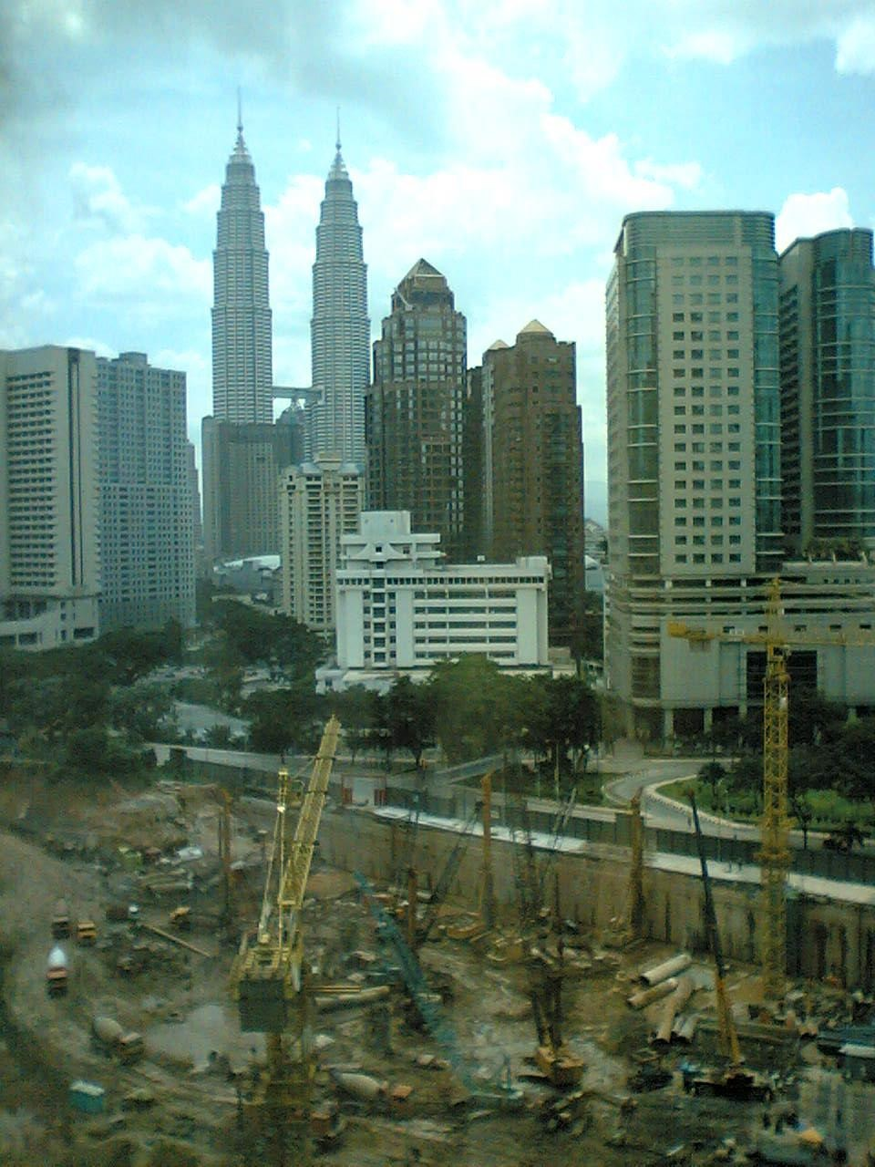

**Image2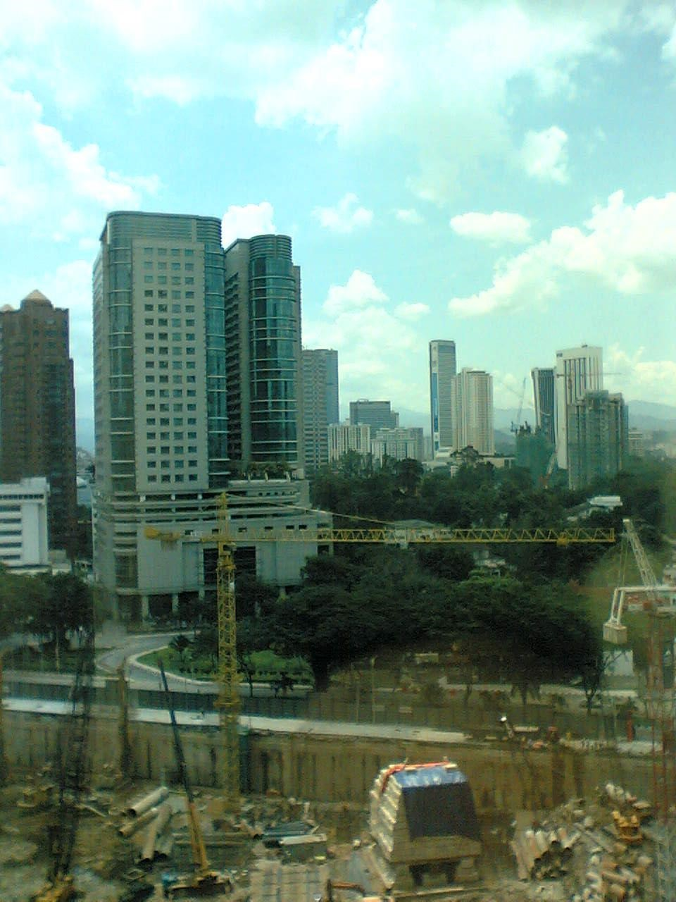 Initial Corner Matching:**

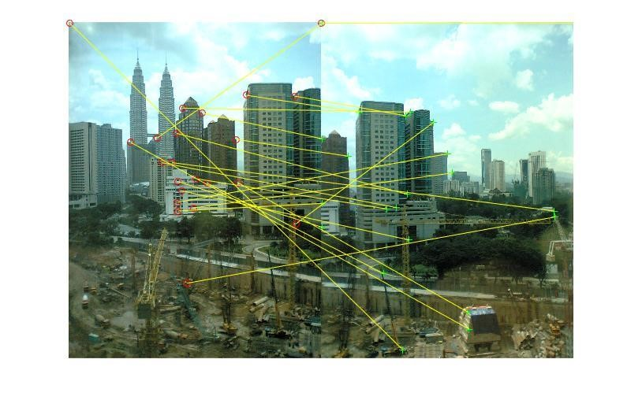

**Final Image after Image Stitching:**

